INTRODUCTION

Departmental store is the place where customers come to purchase their daily using products and pay for that. So there is a need to calculate or generate the bill for the customer. In our project we have 2 users. First is the data entry operator or administrator who will enter the products and its detail in database and also can see the report of any product. Second one is the bill calculating operator who will calculate the bill.

To reduce the bottlenecks of the existing system there is a need to develop a new system. The new system should concern the requirements of the customer and the sellers. It has the following qualities: 1. Reduction in processing cost. 2. Error reduction. 3. Automatic production of the documents and Reports. 4. Faster response time. 5. Flexibility. 6. Reduced dependency. 7. Improves resource uses. 8. Reduction in use of the paper. Proposed system has these qualities including the qualities of the existing system.

Our project has a big scope to do. We can: 1. Calculate the bill. 2. Store products and their prices and with other information. 3. Set the rates of discount on the products. 4. Can see the report of the product.
We can’t: 1. Calculate of the salaries of the employees.2. Calculate the expanses on the product.

OBJECTIVES
“To make software fast in processing, with good user interface so that user can easily operate it and it should be used for a long time without error and maintenance.”

The basic objectives are:

- To make easy for user to calculate or generate the bill of product sold.
- To set different rates of discount on different products.
- In order to reduce the mistakes by automating current system.
- To store products and their prices and with other information.
- To reduce in use of paper.
- To help administration work in easiness and simplest way.
- To use the method of Password encryption.

WHY THE TOPIC IS CHOOSEN

We have chosen this topic Departmental billing system for our project. This is unique than other project of billing system, as it has got the features like password encryption, unique product number and we assume this project has not been prepared before. It is the system to calculate the bill of different products sold in departmental store.

Theoretical Background

Class:
A class is an expanded concept of a data structure: instead of holding only data, it can hold both data and functions. An object is an instantiation of a class. In terms of variables, a class would be the type, and an object would be the variable.
Classes are generally declared using the keyword class, with the following format:
Syntax:
class class_name {
access_specifier_1:
member1;
access_specifier_2:
member2;
...
} object_names;

All is very similar to the declaration on data structures, except that we can now include also functions and members, but also this new thing called access specifier. An access specifier is one of the following three keywords: private, public or protected. These specifiers modify the access rights that the members following them acquire:
- private members of a class are accessible only from within other members of the same class or from their friends.
- protected members are accessible from members of their same class and from their friends, but also from members of their derived classes.
- Finally, public members are accessible from anywhere where the object is visible.
By default, all members of a class declared with the class keyword have private access for all its members. Therefore, any member that is declared before one other class specifier automatically has private access.

Data types:
There are varieties of data types supported by C and C++, each of which may be represented differently within the computer’s memory. The variety of data types allows the programmer to select the type needed by the application. ANSCI c supports three classes of data types:-
- Primary or(fundamental) data types
- User-defined data types
- Derived data types

There are various primary data types and they are:-
- Integer type:
Integers are whole numbers i.e. they are non fractional numbers. Generally they require 16 bit of storage (2 byte). They are used in C by keyword “int”.

- Floating type:
Floating point are the fractional numbers (i.e. real numbers). They are defined in C by keyword “float”. They reserve 32 bits (i.e. 4 bytes) of storage.

- Character type:
A Single character can be defined as a character type data. Characters are stored in 8 bits (i.e. 1 byte). they are used in C by keyword “char”.

Function:

A function is defined as the self –contained block of statements that performs a particular task or job. This is a logical unit composed of a number of statements grouped into a single unit. The function main() is always present in each program which is executed first and other functional are optional.

Syntax:
Return_type function_name(data_type variable1, data_type variable2,…….data_type variablen)
{
………… .
………… .
Statements;
}

Control statements:

The statements which alter the flow of execution of the program are known as control statements. They control the flow of programmes so that it is necessary to execute statements int the same order in which they appear in the program. There are two types of control statements-

Decision making statements
- If statement
- If……else statement
- else if statement
- Nested if….else statement
- Switch statement
Loop or Repeating construct
- for loop
- while loop
- do……while loop

Break statement:
The break statements terminate the execution of the loop and the control is transferred to the statement immediately following the loop. Generally the loop is terminated when the test condition become false. But if we have to terminate the loop instantly without testing the loop termination condition, the break statement is useful.
Syntax:
Break;
It is mostly used in switch statements.

File I/O:

A file just a collection of related data that treated by C++ as a series of bytes. By the way, streams move in one way and in serial fashion from receiver and sender. In other word, a file is a place on the disk where a group of related data is stored. Before a program can write to a file, the program must open it. Opening a file link between the program and the operating system. The include files needed in order to use the disk file I/O class objects are: iostream.h and fstream.h. iostream.h contains standard input output objects such as cin, cout, cerr and clog.
For C++, all file objects belong to the one of the following classes:

Class | Brief Description
ifstream | Objects belong to this class are associated with files opened for input purposes.
ofstream | Objects belong to this class are associated with files opened for output purposes.
fstream | Objects belong to this class are associated with files opened for input and output purposes.

For files you want to read or write, you need a file stream object, e.g.:
ifstream inFile; // object for reading from a file
ofstream outFile; // object for writing to a file

Opening a file:
In order to open a file, use the member function open(). Use it as:
inFile.open(filename, mode);
outFile.open(filename, mode);
where:
- filename is a string that holds the name of the file on disk (including a path like /cs/course if necessary).
- mode is a string representing how you want to open the file. Most often you'll open a file for reading (ios::in) or writing (ios::out or ios::app).

Reading from or writing to a file:
Once a file has been successfully opened, you can read from it in the same way as you would read with cin or write to it in the same way as you write using cout.
1. Opening a file for reading and binary type modes, we could write:
theinputfile.open("testfileio.dat ", ios::in|ios::binary);
2. Opening a file for writing, appending at the end of the file and binary type modes, we could write like this:
theoutputfile.open("testfileio.dat", ios::out|ios::app|ios::binary);

Closing a file:
When done with a file, it must be closed using the member function close(). Closing a file is very important, especially with output files.
inFile.close();
outFile.close();
FLOWCHART
(System Outline)
START

Main menu

Input choice

case 1
Customer option
Create product option
case 1
Yes

Yes

No

View Product Menu option
case 2
Yes

Input choice
No

No

Query option
case 3
Yes

No

Modify Product option
case 4
Yes

No

Delete Product option
case 5
Yes

No

Back to Main Menu option
case 6
Yes

case 2
Yes

Administrator option
No

No

case 3
STOP
Exit option
Yes

No

PROJECT ENVIRONMENT

This project was done in Turbo c++ 3.0 IDE and windows xp was taken as operating system. To run this program the following minimum requirements are needed.

Hardware Requirement:
- 128 MB System Memory
- VGA Graphic
- Keyboard input
- Pentium 1, 500 MHz or above

Software Requirement:
- MS-DOS OPERATING SYSTEM OR ABOVE
- 16 bit operating system and above.

PROGRAM CODING

DMBS.CPP

/*
File : DMBS.cpp
Description : Main working plate from
Author : Dipin Khadka
Created : 08 Jan 2012
-----------------------------------------------------------------------
Date Version Author Description
10 Jan 2012 1.01 Dipin Class created
12 Jan 2012 1.02 Dipin Added logic to write and display searched product record
13 Jan 2012 1.03 Dipin Added logic to modify and delete record
14 Jan 2012 1.04 Dipin Added logic to show product menu and placing order
16 Jan 2012 1.05 Dipin Added logic to display main, admin menu and
to check unique product number
*/

#include<conio.h>
#include<stdio.h>
#include<process.h>
#include<graphics.h>
#include<fstream.h>
#include<string.h>
#include<stdlib.h>
#include<dos.h>

#include"common.cpp"
#include"util.cpp"
class product
{
int pno;
char name[50];
double price,qty,dis;
public:
void takeProductDetail();
void showProduct();
void createProduct();
void displayQueryProduct();
void modifyProduct();
void deleteProduct();
void showProductMenu();
void placeOrder();
int checkUniquePno(int no);

}; //class ends here

class menu
{
public:
void adminMenu();
};
/* global declaration for stream object and objects */
fstream fp;
product pr;
menu mn;

int product::checkUniquePno(int no)
{
/*
Description : For checking unique product number
Author : Dipin Khadka
Created : 16 Jan 2012
*/
int flag = 0;

fp.open("Shop.dat",ios::in|ios::binary);
if(!fp)
{
return -1;
}
else
{
while(fp.read((char*)&pr,sizeof(product)))
{
if(pno == no)
{
flag = 1;
break;
}
}
}/* end of else */
fp.close();
return flag;

}/* end of checkUniquePno */

void product::takeProductDetail()
{
/*
Description : For creating product
Author : Dipin Khadka
Created : 10 Jan 2012
*/
int flag = 0;
int num = 0;
gotoxy(3,3); cout<<"\tEnter Products Details";
gotoxy(3,4); cout<<"\t_______________________";
gotoxy(3,5); cout<<"Product Number : ";
while(1)
{
num = getInt(21,5,4);
flag = checkUniquePno(num);
if(flag == 1)
{
gotoxy(3,12);
cout<<" Product no must be unique.Re-enter product no: ";
sleep(2); /* statement will be displayed
at screen only for 2 seconds*/
gotoxy(3,12); cout<<" ";
gotoxy(21,5); cout<<" ";
gotoxy(21,5);
}
else if(flag == -1)
{
gotoxy(3,12); cout<<"This is the first record...";
sleep(2);
gotoxy(3,12); cout<<" ";
break;
}
else if(flag == 0)
{
break;
}
} /* end of while*/
pno = num;
gotoxy(3,7);cout<<"Name : ";
getString(21,7,25,name);
gotoxy(3,9);cout<<"Price : ";
price=getInt(21,9,4);
gotoxy(3,11);cout<<"Discount Rate(%) : ";
getCursor(21,11,2);
gotoxy(22,11);cin>>dis;
removeCursor(21,11,2);
}/*end of takeProductDetail */

void product::showProduct()
{
/*
Description : Function to show product
Author : Dipin Khadka
Created : 12 Jan 2012
*/
gotoxy(3,7);cout<<"*********************************************";
gotoxy(3,8);cout<<" DETAILS ";
gotoxy(3,9);cout<<"*********************************************";
gotoxy(3,11);cout<<"PRODUCT NO. : "<<pno;
gotoxy(3,13);cout<<"PRODUCT NAME : "<<name;
gotoxy(3,15);cout<<"PRICE : Rs."<<price;
gotoxy(3,17);cout<<"DISCOUNT RATE(in %) : "<<dis;
gotoxy(3,18);cout<<"*********************************************";
}/* end of showProduct */

void product::createProduct()
{
/*
Description : Function to write in file
Author : Dipin Khadka
Created : 12 Jan 2012
*/
char answer = NULL;
cleardevice();
border();
pr.takeProductDetail();
fp.open("Shop.dat",ios::out|ios::app|ios::binary);
if(!fp)
{
gotoxy(5,5);cout<<"ERROR!!! FILE COULD NOT BE OPEN!!";
gotoxy(5,7);cout<<"Program is closing ....";
getch();
closegraph();
exit(-1);
}
else
{
fp.write((char*)&pr,sizeof(product));
gotoxy(3,17); cout<<"The Product Has Been Created!!";
}
fp.close();
delay(700);
gotoxy(3,17); cout<<"Would you like to create more products(Y/N)?";
answer = getch();
if(answer == 'y' || answer == 'Y')
{
pr.createProduct();
}
gotoxy(3,17); cout<<" ";
gotoxy(3,17); cout<<"Press any key to return to admin menu...";
getch();
}/*end of createProduct */

void product::displayQueryProduct()
{
/*
Description : Function to read specific record from file
Author : Dipin Khadka
Created : 12 Jan 2012
*/

int num = 0;
int flag = 0;
char answer = NULL;
cleardevice();
border();

fp.open("Shop.dat",ios::in|ios::binary);

if(!fp)
{
gotoxy(5,5);cout<<"ERROR!!! FILE COULD NOT BE OPEN!!";
gotoxy(5,7);cout<<"Program is closing ....";
getch();
closegraph();
exit(-1);
}
gotoxy(3,2);cout<<"_____________";
gotoxy(3,3);cout<<"Query product";
gotoxy(3,4);cout<<"_____________";
getCursor(32,6,4);
gotoxy(3,6);cout<<"Please Enter The Product No.:";
gotoxy(33,6);cin>>num;
while(fp.read((char*)&pr,sizeof(product)))
{
if(pno==num)
{
showProduct();
flag=1;
}
}
fp.close();
if(flag==0)
{
gotoxy(3,13);cout<<"record not exist!!";
}
delay(700);
gotoxy(3,20); cout<<"Would you like to query more products(Y/N)?";
answer = getch();
if(answer == 'y' || answer == 'Y')
{
displayQueryProduct();
}
delay(200);
gotoxy(3,20); cout<<" ";
gotoxy(3,20); cout<<"Press any key to return to admin menu...";
getch();

}/* end of displayQueryProduct */

void product::modifyProduct()
{
/*
Description : Function to modify record of file
Author : Dipin Khadka
Created : 13 Jan 2012
*/

int num = 0;
int flag = 0;
char answer = NULL;
cleardevice();
border();

fp.open("Shop.dat",ios::in|ios::out|ios::binary);
if(!fp)
{
gotoxy(5,5);cout<<"ERROR!!! FILE COULD NOT BE OPEN!!";
gotoxy(5,7);cout<<"Program is closing ....";
getch();
closegraph();
exit(-1);
}
gotoxy(3,2);cout<<"______________";
gotoxy(3,3);cout<<"Modify Product";
gotoxy(3,4);cout<<"______________";
gotoxy(3,6);cout<<"Please Enter The Product No. to modify:";
getCursor(43,6,4);
gotoxy(44,6);cin>>num;
while(fp.read((char*)&pr,sizeof(product)) && flag == 0)
{
if(pno==num)
{
showProduct();
gotoxy(3,20);
cout<<"Press any key for modify this record...";
getch();
cleardevice();
border();
gotoxy(3,4);
cout<<"\tEnter Products Details";
gotoxy(3,5); cout<<"\t_______________________";
gotoxy(3,7);cout<<"Name : ";
getString(21,7,25,name);
gotoxy(3,9);cout<<"Price : ";
price=getInt(21,9,4);
gotoxy(3,11);cout<<"Discount Rate(%) : ";
getCursor(21,11,2);
gotoxy(22,11);cin>>dis;
removeCursor(21,11,2);
int pos=-1*sizeof(pr);
fp.seekp(pos,ios::cur);
fp.write((char*)&pr,sizeof(product));
gotoxy(3,13);cout<<" Record Updated!!";
flag=1;
}
}
fp.close();
if(flag == 0)
{
gotoxy(3,13);cout<<" Record Not Found!! ";
}
delay(700);
gotoxy(3,17); cout<<"Would you like to modify more products(Y/N)?";
answer = getch();
if(answer == 'y' || answer == 'Y')
{
modifyProduct();
}
delay(200);
gotoxy(3,17); cout<<"Press any key to return to admin menu... ";
getch();
}/* end of modifyProduct */

void product::deleteProduct()
{
/*
Description : Function to delete record of file
Author : Dipin Khadka
Created : 13 Jan 2012
*/
int no = 0;
int flag = 0;
char answer = NULL;
cleardevice();
border();
gotoxy(3,2);cout<<"_____________";
gotoxy(3,3);cout<<"Delete Record";
gotoxy(3,4);cout<<"_____________";
getCursor(67,6,4);
gotoxy(3,6);
cout<<"Please Enter The product no of The Product You Want To Delete:";
gotoxy(68,6);cin>>no;
fp.open("Shop.dat",ios::in|ios::out|ios::binary);
fstream fp2;
fp2.open("Temp.dat",ios::out|ios::binary);
fp.seekg(0,ios::beg);
while(fp.read((char*)&pr,sizeof(product)))
{
if(pno==no)
{
flag = 1;
showProduct();
gotoxy(3,20);
cout<<"Are you sure to delete this record(Y/N)?";
answer = getch();

if(answer == 'y' || answer == 'Y')/* checks yes or no*/
{
flag = 2;
continue;
}
}
fp2.write((char*)&pr,sizeof(product));
}
fp2.close();
fp.close();
remove("Shop.dat");
rename("Temp.dat","Shop.dat");

cleardevice();
border();
if(flag == 1)
{
gotoxy(3,10); cout<<"Record has not been deleted!!";
}
else if(flag == 2)
{
gotoxy(3,10); cout<<"Record deleted!!";
}
else if(flag == 0)
{
gotoxy(3,10); cout<<"Sorry!!! No any record found!!";
}
delay(400);
gotoxy(3,15); cout<<"Would you like to delete more records(Y/N)?";
answer = getch();
if(answer == 'y' || answer == 'Y')
{
deleteProduct();
}
}/* end of deleteProduct */

void product::showProductMenu()
{
/*
Description : Function to display record from file
Author : Dipin Khadka
Created : 14 Jan 2012
*/
int i = 2;
cleardevice();
border();
fp.open("Shop.dat",ios::in|ios::binary);
if(!fp)
{
gotoxy(5,5);cout<<"ERROR!!! FILE COULD NOT BE OPEN!!";
gotoxy(5,7);cout<<"Go To Admin Menu to create File";
gotoxy(5,9);cout<<"Program is closing ....";
getch();
closegraph();
exit(-1);
}
gotoxy(3,2);cout<<"____________";
gotoxy(3,3);cout<<"PRODUCT MENU";
gotoxy(3,4);cout<<"____________";
gotoxy(3,6);cout<<"P.NO.\t\tNAME\t\t\tPRICE\t\tDISCOUNT RATE";
gotoxy(3,7);cout<<"====================================================================";

while(fp.read((char*)&pr,sizeof(product)))
{
gotoxy(4,7+i); cout<<pno;
gotoxy(17,7+i); cout<<name;
gotoxy(41,7+i); cout<<"Rs."<<price;
gotoxy(60,7+i); cout<<dis<<"%"<<endl;
i=i+2;

if(i%16 == 0)
{
i=2;
gotoxy(3,24);
cout<<"Press any key for more...";
getch();
cleardevice();
border();
gotoxy(3,2);cout<<"____________";
gotoxy(3,3);cout<<"PRODUCT MENU";
gotoxy(3,4);cout<<"____________";
gotoxy(3,6);
cout<<"P.NO.\t\tNAME\t\t\tPRICE\t\tDISCOUNT RATE";
gotoxy(3,7);
cout<<"====================================================================";
}
}/*end of while */
fp.close();
gotoxy(3,24);cout<<" ";
gotoxy(3,24);cout<<"Press any key to return to admin menu..";
getch();
}/ * end of showProducMenu */

void product::placeOrder()
{
/*
Description : Function to place order and generating bill for Products
Author : Dipin Khadka
Created : 14 Jan 2012
*/
int order_arr[50], quan[50];
int i = 0;
int n = 0;
int num = 0;
int flag = 0;
int count = 0;
float amount = 0;
float amtAfterDis = 0;
float total = 0;
char ch = NULL;

cleardevice();
border();
gotoxy(3,3);cout<<"****************************";
gotoxy(3,4);cout<<" PLACE YOUR ORDER";
gotoxy(3,5);cout<<"****************************";
do
{
if(count<5)
{
gotoxy(3,7); cout<<"Enter The Product NO. : ";
while(1)
{
num = getInt(27,7,4);
flag = checkUniquePno(num);

if(flag == 0)
{
gotoxy(3,12);
cout<<"Sorry!! This product no. is not available...";
getch();
sleep(2); /* statement will be displayed
at screen only for 2 seconds*/
gotoxy(3,12);
cout<<" ";
gotoxy(27,7); cout<<" ";
gotoxy(27,7);
}
else if(flag == 1 || flag == -1)
{
break;
}
}
order_arr[i] = num;
gotoxy(3,9); cout<<"Quantity in number : ";
quan[i] = getInt(27,9,4);
i++;
count++;
}
else
{
gotoxy(3,15);
cout<<"Only 5 items at a time can be ordered!!";
getch();
ch = 'n';
goto afterCinCh;
}
gotoxy(3,15);
cout<<"Thank You For Placing The Order!!";
getch();
gotoxy(3,17);
cout<<"Do You Want To Order Another Product(y/n)?";
cin>>ch;
afterCinCh:
if(ch == 'y' || ch == 'Y')
{
cleardevice();
border();
gotoxy(3,3);cout<<"****************************";
gotoxy(3,4);cout<<" PLACE YOUR ORDER";
gotoxy(3,5);cout<<"****************************";
}
}while(ch=='y' ||ch=='Y');

cleardevice();
border();
gotoxy(3,3);
cout<<"*********************************************************";
gotoxy(3,4);cout<<" INVOICE ";
gotoxy(3,5);
cout<<"*********************************************************";
gotoxy(3,7);
cout<<"Pr No. Pr Name Quantity Price Amount Amt After Dis";
gotoxy(3,8);
cout<<"_____________________________________________________________________________";
for(int x=0;x<=i;x++)
{
fp.open("Shop.dat",ios::in|ios::binary);
fp.read((char*)&pr,sizeof(product));
while(!fp.eof())
{
if(pno==order_arr[x])
{
amount = price*quan[x];
amtAfterDis = amount-(amount*dis/100);
gotoxy(4,10+n); cout<<order_arr[x];
gotoxy(11,10+n); cout<<name;
gotoxy(27,10+n); cout<<quan[x];
gotoxy(36,10+n); cout<<"Rs."<<price;
gotoxy(48,10+n); cout<<"Rs."<<amount;
gotoxy(59,10+n); cout<<"Rs."<<amtAfterDis;
total=total + amtAfterDis;
n=n+2;
}
fp.read((char*)&pr,sizeof(product));
}

fp.close();
}
gotoxy(3,10+n); cout<<"\t\t_____________";
gotoxy(3,11+n); cout<<"\t\tTOTAL AMOUNT = Rs."<<total;
gotoxy(3,12+n); cout<<"\t\t_____________";
getch();
}/* end of placeOrder */

void menu::adminMenu()
{
/*
Description : Adminstrator menu function
Author : Dipin Khadka
Created : 16 Jan 2012
*/
char choice2 = NULL;
do
{
cleardevice();
coverBorder();
displayIntro();
rectangle(180,127,330,162);
gotoxy(28,10);cout<<"ADMIN MENU";
gotoxy(23,12);cout<<"1.CREATE PRODUCT";
gotoxy(23,14);cout<<"2.VIEW PRODUCT MENU";
gotoxy(23,16);cout<<"3.QUERY ";
gotoxy(23,18);cout<<"4.MODIFY PRODUCT";
gotoxy(23,20);cout<<"5.DELETE PRODUCT";
gotoxy(23,22);cout<<"6.BACK TO MAIN MENU";
getCursor(57,24,2);

gotoxy(23,24);cout<<"Please Enter Your Choice (1-6): ";
gotoxy(58,24);cin>>choice2;

switch(choice2)
{
case '1':
pr.createProduct();
break;
case '2':
pr.showProductMenu();
break;
case '3':
pr.displayQueryProduct();
break;
case '4':
pr.modifyProduct();
break;
case '5':
pr.deleteProduct();
break;
case '6':
break;

default:cout<<"\a";

}
}while(choice2!='6');
}/* end of adminMenu */

void main()
{
/*
Description : Main function of the program
Author : Dipin Khadka
Created : 10 Jan 2012
*/
clrscr();
char userName[20];
char userPassword[20];
char fileUserName[20] = "admin";
char filePassword[20] = "password";
int attempt = 3;
char choice = NULL;
initgraphics();
highvideo();
do
{
starting:
cleardevice();
coverBorder();
displayIntro();
members();
rectangle(410,170,230,130);
gotoxy(34,10);cout<<"LOGIN SECTION";
rectangle(410,250,230,180);
gotoxy(31,13);cout<<"Admin : ";
gotoxy(31,15);cout<<"Password: ";
getString(40, 13, 9, userName);
getPassword(40, 15, 9, userPassword);
if(strcmp(userPassword,filePassword)==0 && strcmp(userName,fileUserName)==0) /* checks the valid password*/
{
greet();
afterLogin:
attempt = 3;
cleardevice();
coverBorder();
displayIntro();
rectangle(180,127,330,162);
gotoxy(28,10); cout<<"MAIN MENU";
gotoxy(23,12); cout<<"1. CUSTOMER";
gotoxy(23,14); cout<<"2. ADMINISTRATOR";
gotoxy(23,16); cout<<"3. EXIT";
getCursor(57,18,2);
gotoxy(23,18);cout<<"Please Select Your Option (1-3): ";
gotoxy(58,18);cin>>choice;
switch(choice)
{
case '1':
pr.placeOrder();
goto afterLogin;
case '2':
mn.adminMenu();
goto afterLogin;
case '3':
terminateScreen();
closegraph();
exit(0);

default : cout<<"\a";
}
}/* end of if */
else
{
gotoxy(36,19); cout<<" ";
gotoxy(35,21); cout<<" ";
gotoxy(36,22); cout<<" ";
gotoxy(31,23); cout<<" ";
gotoxy(32,24); cout<<" ";
if(attempt>1)
{
attempt--;
gotoxy(30,22); cout<<"Please!!! Try again!!!";
gotoxy(33,23); cout<<"Attempt left:"<<attempt;
getch();
gotoxy(33,23); cout<<" ";
goto starting;

}

else
{
gotoxy(23,22);
cout<<"Maximum Number of Attempts Exceeded!!!";
gotoxy(26,23); cout<<"System is going to shutdown...";
sleep(3);
terminateScreen();
closegraph();
exit(0);
}
} /*end of else*/
}while(choice!='3');
}/* end of main */

COMMON.CPP

/*
File : COMMON.cpp
Description : Common functions
Author : Dipin Khadka
Created : 12 Jan 2012
------------------------------------------------------------------
Date Version Author Description
12 Jan 2012 1.01 Dipin Kepping common functions
*/

int m = 0;
int mx = 640;
int my = 410;
int d = 0;

UTIL.CPP
/*
File : UTIL.cpp
Description : Password creating
Author : Dipin Khadka
Created : 17 Jan 2012
------------------------------------------------------------------
Date Version Author Description
12 Jan 2011 1.01 Dipin Added logic to display styles
17 Jan 2011 1.02 Dipin Added logic to password, string and
integer creation
*/
void initgraphics()
{
/*
Description : Function to initialise graphics
Author : Dipin Khadka
Created : 12 Jan 2012
*/
d=DETECT;
initgraph(&d,&m,"c:\\tc\\bgi");

}/* end of initgaphics */

void border()
{
/*
Description : For border each page
Author : Dipin Khadka
Created : 12 Jan 2012
*/
setcolor(WHITE);
rectangle(2,2,mx-2,my-2);
setcolor(RED);
rectangle(4,4,mx-4,my-4);
setcolor(WHITE);
rectangle(6,6,mx-6,my-6);

}/* end of border */

void coverBorder()
{
/*
Description : For border main page
Author : Dipin Khadka
Created : 12 Jan 2012
*/
setcolor(WHITE);
rectangle(140,2,500,400);
setcolor(RED);
rectangle(142,4,498,398);
setcolor(WHITE);
rectangle(144,6,496,396);
setcolor(WHITE);
line(144,100,496,100);
setcolor(RED);
line(144,102,496,102);
setcolor(WHITE);
line(144,104,496,104);
}/* end of coverBorder */

void displayIntro()
{
/*
Description : Function to display introduction
Author : Dipin Khadka
Created : 12 Jan 2012
*/
char *name = "GREEN VALLEY DEPARTMENTAL STORE";
char *add = "HATTIGAUDA, KATHMANDU";
char *estd = "ESTD. 2010";

gotoxy(25,3); cout<<name;
gotoxy(30,4); cout<<add;
gotoxy(35,5); cout<<estd;

}/* end of displayIntro*/

void members()
{
/*
Description : Function to display members name
Author : Dipin Khadka
Created : 12 Jan 2012
*/
char *dBy = "DESIGNED BY";
char *name2= "DIPIN KHADKA";
char *name1= "AMAN MANANDHAR";
char *name3= "RAJINDRA PRASAD KAFLE";
char *name4= "SHREEKANT CHAUDHARY";

gotoxy(36,19); cout<<dBy;
gotoxy(35,21); cout<<name1;
gotoxy(36,22); cout<<name2;
gotoxy(31,23); cout<<name3;
gotoxy(32,24); cout<<name4;

}/* end of members */

void greet()
{
/*
Description : Function to display greeting
Author : Dipin Khadka
Created : 12 Jan 2012
*/
char *greet= "WELCOME TO THIS SOFTWARE...";
int i = 0;
cleardevice();
coverBorder();
displayIntro();
//for displaying greeting
for(i=0;i<strlen(greet);i++)
{
delay(200);
gotoxy(29+i,15); cout<<greet[i];
}
sleep(1); //after 1 seconds screen will be disappear
}/* end of greet */

void terminateScreen()
{
/*
Description : Function to display colsing message
Author : Dipin Khadka
Created : 12 Jan 2012
*/

int i =0;
char *greet = "THANK YOU VISIT AGAIN...";
cleardevice();
coverBorder();
displayIntro();

// for displaying greeting
for(i=0;i<strlen(greet);i++)
{
delay(200);
gotoxy(27+i,15); cout<<greet[i];
}
sleep(2);

}/* end of terminateScreen*/

void getPassword(int x, int y, int max, char userPassword[30])
{
/*
Description : Password creating
Author : Dipin Khadka
Created : 17 Jan 2012
*/

char ch = NULL;
int i = 0;
int count = 0;

while(1)
{
gotoxy(x,y);cout<<"[";
gotoxy(x+1+i,y); cout<<"]";
ch = getch();
if(ch == 13) /* for enter key */
{
break;
}

if(ch == 8) /* for backspace */
{
gotoxy(x+i,y); cout<<" ";
gotoxy(x+i+1,y); cout<<" ";
if(i>0)
{
i--;
count--;
}
}
else if(i<max) /*for accepting characters until maximum level is reached*/
{
userPassword[i] = ch;
i++;
gotoxy(x+i,y); cout<<"*";
count++;
}
}/* end of while*/
if(count < 6) /* for displaying warning if charecters not met minimum level */
{
gotoxy(36,19); cout<<" ";
gotoxy(35,21); cout<<" ";
gotoxy(36,22); cout<<" ";
gotoxy(31,23); cout<<" ";
gotoxy(32,24); cout<<" ";
gotoxy(20,y+7); cout<<"Password should be at least 6 character..";
sleep(2);
gotoxy(20,y+7); cout<<" ";
}/* end of if*/
userPassword[i] = NULL;
gotoxy(x,y);cout<<" ";
gotoxy(x+1+i,y); cout<<" ";
}/* end of getPassword*/

void getString(int x, int y, int max, char str[30])
{
/*
Description : String creating
Author : Dipin Khadka
Created : 17 Jan 2012
*/

char ch = NULL;
int i = 0;
int count = 0;

while(1)
{
while(1)
{
gotoxy(x,y);cout<<"[";
gotoxy(x+1+i,y); cout<<"]";
ch = getch();

if(ch == 13) /* for enter key */
{
break;
}
if(ch == 8) /* for backspace */
{
gotoxy(x+i,y); cout<<" ";
gotoxy(x+i+1,y); cout<<" ";

if(i>0)
{
i--;
count--;
}
}
else if(i<max) /*for accepting characters
until maximum level is reached*/
{
str[i] = ch;
i++;
gotoxy(x+i,y); cout<<ch;
count++;
}
}/* end of while*/
str[i] = NULL;
if(strlen(str)!= 0 )
break;
}
gotoxy(x,y);cout<<" ";
gotoxy(x+1+i,y); cout<<" ";
}/* end of getString*/

int getInt(int x, int y, int max)
{
/*
Description : Integer creating
Author : Dipin Khadka
Created : 17 Jan 2012
*/

char str[30];
int temp = 0;
char ch = NULL;
int i = 0;
int count = 0;

while(1)
{
while(1)
{
while(1)
{
gotoxy(x,y);cout<<"[";
gotoxy(x+1+i,y); cout<<"]";
ch = getch();
if((ch >=48 && ch <= 57) || ch == 13 || ch == 8)
break;
}/* end of 1 while*/
if(ch == 13) /* for enter key */
{
break;
}
if(ch == 8) /* for backspace */
{
gotoxy(x+i,y); cout<<" ";
gotoxy(x+i+1,y); cout<<" ";

if(i>0)
{
i--;
count--;
}
}
else if(i<max) /*for accepting characters
until maximum level is reached*/
{
str[i] = ch;
i++;
gotoxy(x+i,y); cout<<ch;
count++;
}
}/* end of 2nd while*/

str[i] = NULL;
temp = atoi(str); /* converts the string into integer and returns it*/

if(temp != 0 )
break;
}/*end of 3rd while*/

gotoxy(x,y);cout<<" ";
gotoxy(x+1+i,y); cout<<" ";
return temp;

}/* end of getInt*/

void getCursor(int x, int y, int range)
{
/*
Description : Bracket creating for indication
Author : Dipin Khadka
Created : 17 Jan 2012
*/
gotoxy(x,y); cout<<"[";
gotoxy(x+range,y); cout<<"]";
}/* end of getCursor */

void removeCursor(int x, int y, int range)
{
/*
Description : Bracket removing
Author : Dipin Khadka
Created : 17 Jan 2012
*/
gotoxy(x,y); cout<<" ";
gotoxy(x+range,y); cout<<" ";
}/* end of removeCursor */

USER OPERATIONAL MANNUAL

Departmental billing system is the system to calculate the bill of different products sold in departmental store.

first of all login screen appears which contains the detail of the departmental store and designer of the program. We have to enter correct admin name and password for getting started.
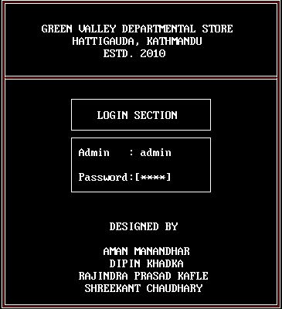

After that if password and admin name is correct, then welcome screen appears.

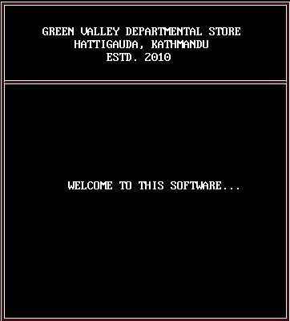

If not, we can enter admin and password for 2 times more and after that system will be close automatically.
After that, the main menu will appear which shows the 3 menu items as shown below.

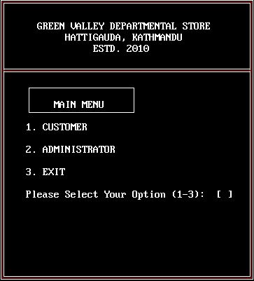

1. CUSTOMER OPTION

Press 1 for accessing the customer option. This option is one of the important function of this program which calculate the bill for sold product item. For this we have to enter product number and product’s quantity.
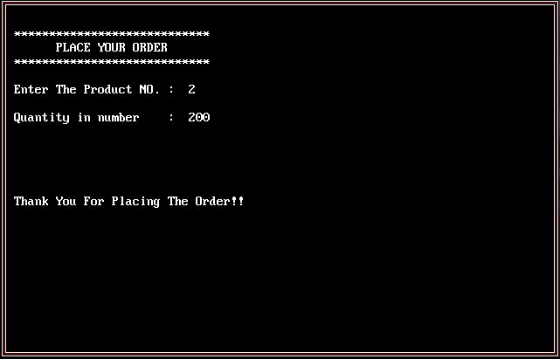

After that it displays message for ordering more. If we press y, we can order more but only five items at a time. If we press n, it display invoice or generate bill as shown below.
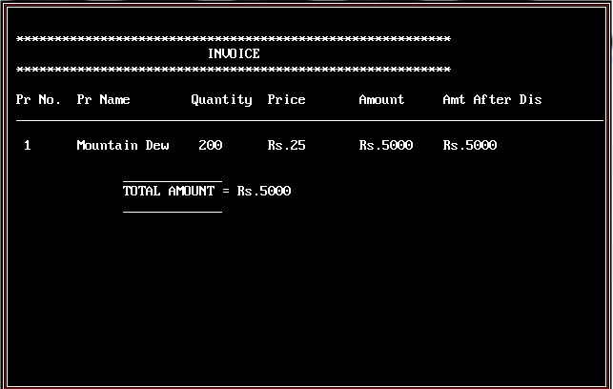

2. ADMINSTRATOR OPTION

Press 2 for accessing this option. It contains 6 options as shown below.

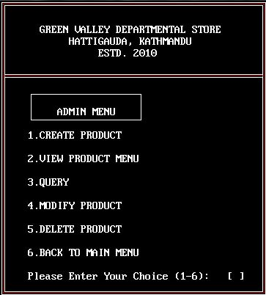

Create Product option
For this option, we have to press 1. From this, we can create product with products no. which is unique, product name, price and the discount rate in percentage.

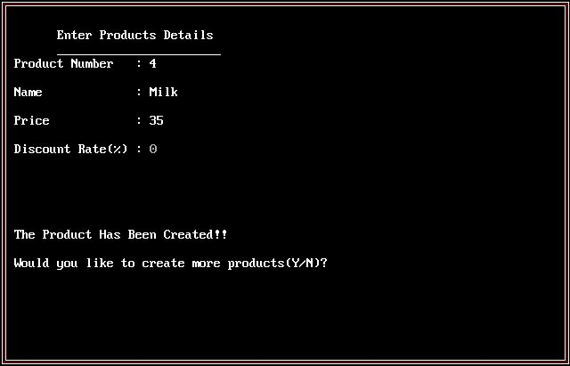

After that, it asks for add more record or not. If pressed y, we can add more records. If not, it returns to admin menu.

Every time when we add record, we should enter product no. unique.
If it is not, it displays message and we have to enter the unique product no. again. Message will be displayed at screen is “Product no must be unique.. Re-enter product no:” for 2 seconds only.
If record was first it displays “This is the first record…”.

View Product Menu option:

On pressing the second option we can view all the product 7 items at a time.
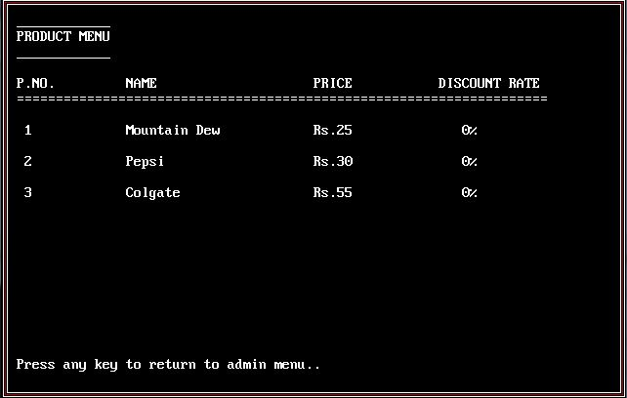

If there is no any record saved, it displays “Sorry!!! No any record exists..” message.

Query Product option

On pressing third option we can search product.
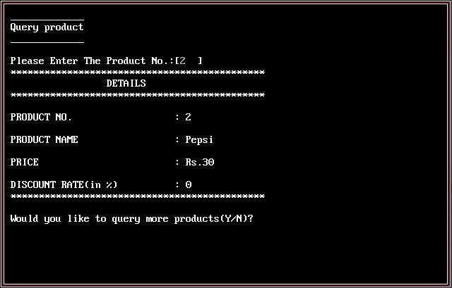

If record was not save or found it displays following message “Record Not Found!!”.

Modify option:

on pressing the fourth option we can modify the product records. As follows:
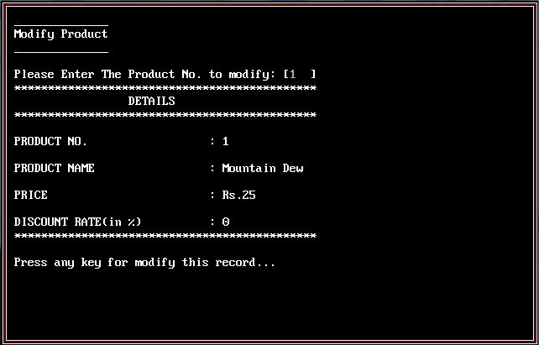

And we have to enter Product no. to modify any record that was saved already and it displays that record. And then, we can modify that record.

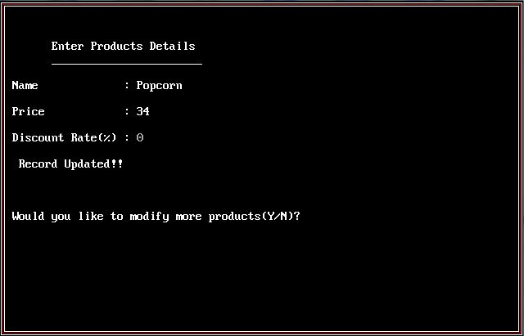

After completing modifying, it displays “Record Updated!!” message and “Would you like to modify more products(Y/N)?” as shown above figure. If pressed y, we can modify more records. If not, it returns to admin menu.

Delete option:

On pressing the fifth option we can delete the saved product record one by one
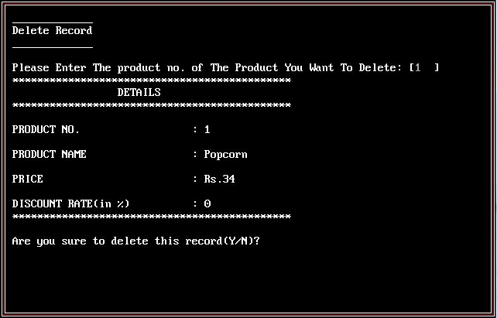

We have to enter product no. to delete record. If record was saved, it displays the record and asks for sure to delete record as shown in above figure. If pressed y, it deletes the record and shows “Record deleted!!” message. If not, it displays “Record has not been deleted!!!” message.
If record was not saved, it displays the following message “Sorry!!! No any record found!!!”.

Back to main menu option:

On pressing the sixth option we can return back to the main menu.

Note:
After every option it displays for returning to admin menu.

3. Exit option

Press 3 for exiting or closing system.
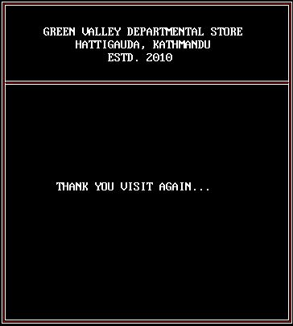

It will appear only for 2 seconds and then system will be closed automatically.

Note:

If any problem occurs during opening of file, it displays following message

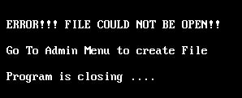

CONCLUSION

Our project is on Departmental Store Billing System. We have successfully completed it. We take this opportunity to express our sense of indebtedness and gratitude to all those people who helped us in completing this project. We are immensely grateful to our esteemed faculty guide Assistant Mr. Anish Panthi and other faculties for their supervision and guidance without which this work would not have been possible.

This project has contributed a lot to our knowledge that has proved to be a value addition for us.

REFERENCES

- http://www.mycplus.com
- www.cprogramming.com
- Object Oriented Programming With C++, E Balagurusamy
- Mr. Anish pd. Panthi
- Mr. Sijan Gurung

